**LocationList Page Design**

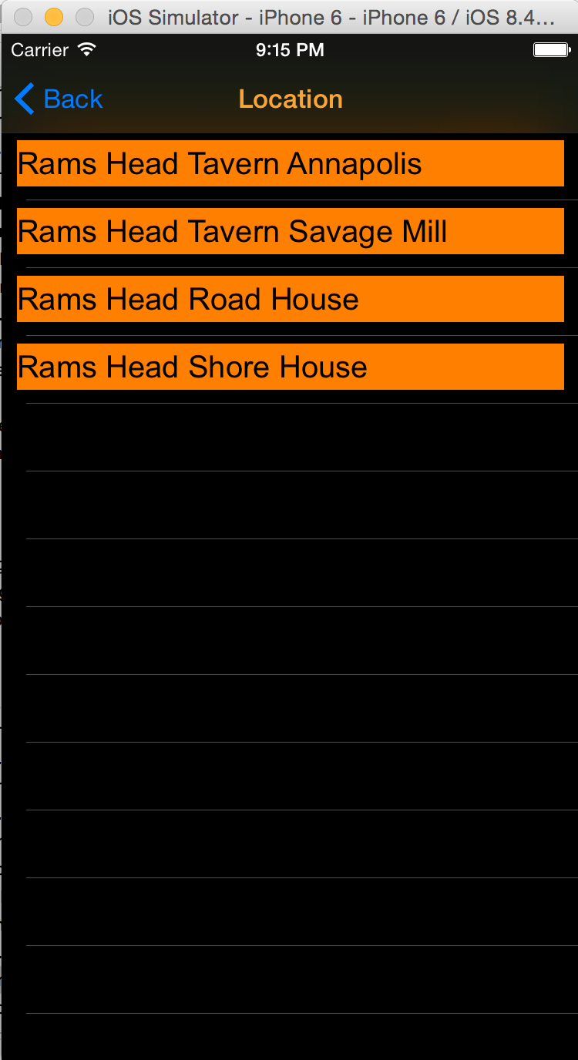**Elements:**

Title: Location, orange

Navigation Buttom: “Back”, blue; back to last page(menu)

View Backgroud: black

Cell Background: black

Cell content:

Label, orange background, black text

List all restaurant names

Cells Separator: red single line